Perfect!
I will now give you a very clean, very simple, beginner-friendly step-by-step procedure to create your Jack Marvels – Influencers Challenge 2026 form in Microsoft Forms from scratch.
Follow each step exactly — you will finish the entire form smoothly in 10–15 minutes.

⭐ STEP–BY–STEP PROCEDURE: Create Your Stylish Microsoft Form
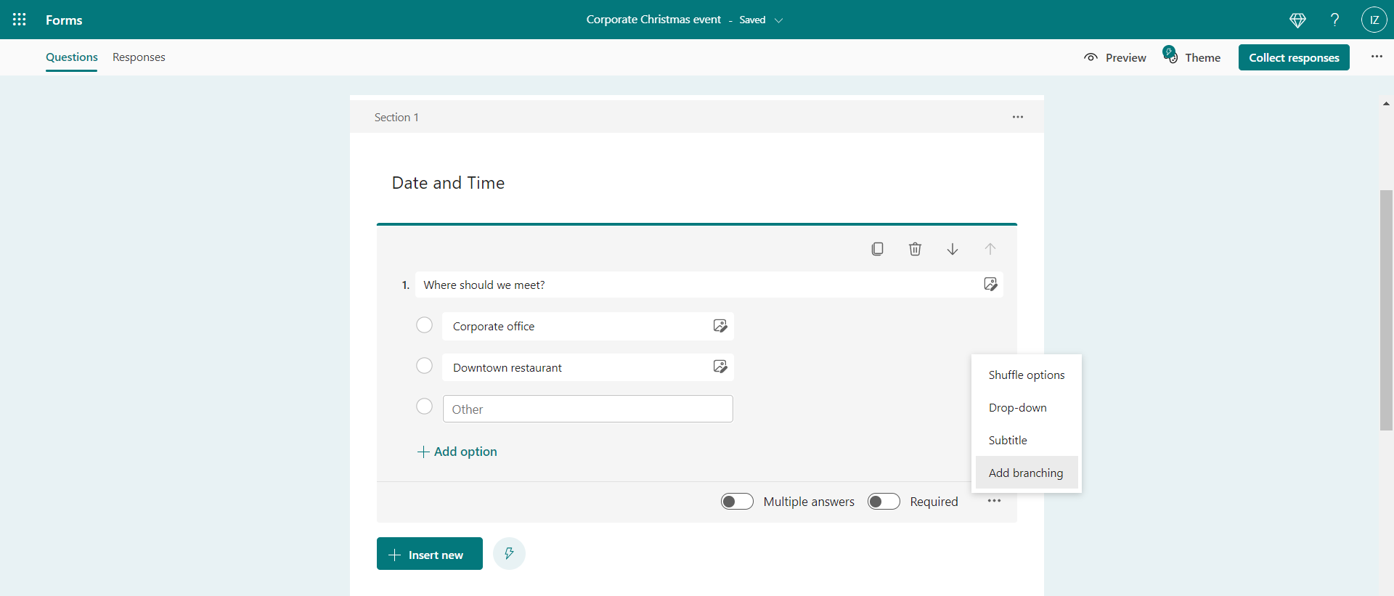
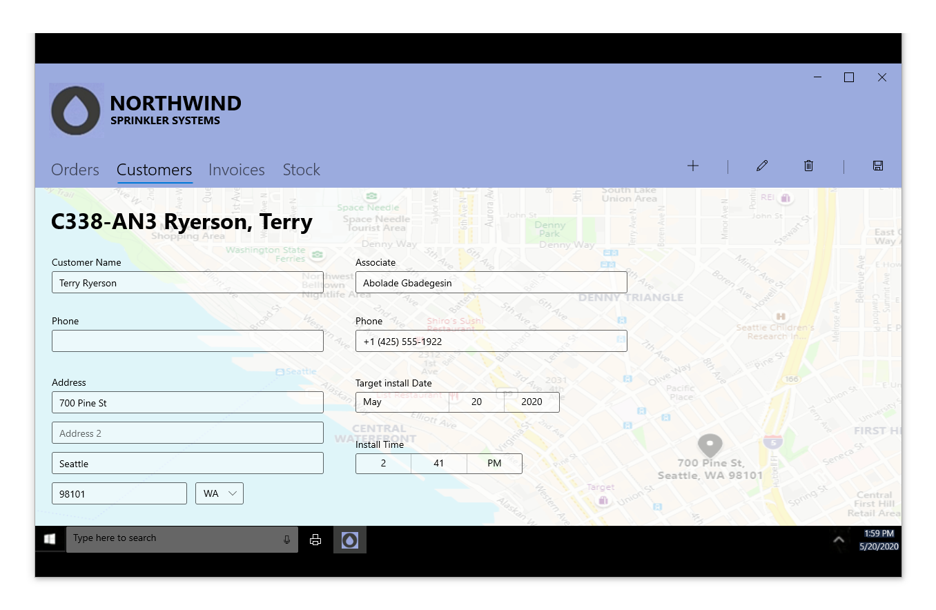
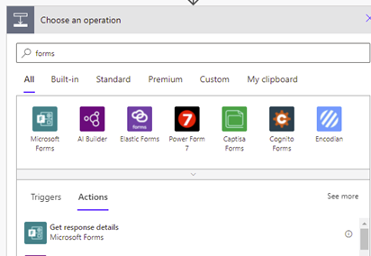
4

✅ STEP 1: Open Microsoft Forms
- Go to: https://forms.microsoft.com
- Log in with any email (Gmail/Outlook/Hotmail)
- You will see the dashboard

✅ STEP 2: Click “New Form”
This creates a blank form.

✅ STEP 3: Add Form Title & Description
At the top:

Title:
Jack Marvels – Influencers Challenge 2026

Description:
Fill the following details to participate in our Influencers Challenge. This is the official onboarding form for our launch event.

✅ STEP 4: Start Adding Questions
Click + Add new for each question.
I’ll guide you EXACTLY what type to select.

⭐ SECTION 1 — Personal Info

Question 1: Full Name
- Type: Text
- Required: ON

Question 2: Social Media Handle / Stage Name
- Type: Text
- Required: ON

Question 3: Gender
- Type: Choice
- Options:
  - Male
  - Female
  - Prefer not to say
- Required: ON

Question 4: Age Category
- Type: Choice
- Options:
  - Under 18
  - 18–25
  - 26–35
  - 35+
- Required: ON

⭐ SECTION 2 — Contact Details

Question 5: Location (City)
- Type: Text
- Required: ON

Question 6: Email (For official communication)
- Type: Text
- Settings → Restrict to email (turn ON)
- Required: ON

Question 7: Contact Number
- Type: Text
- Settings → Restrict to Number (if available)
- Required: ON

⭐ SECTION 3 — Influencer Profile

Question 8: Primary Platform Link (Instagram, YouTube, etc.)
- Type: Text
- Required: ON

Question 9: Total Followers Count
- Type: Text
- Required: ON

Question 10: Category
- Type: Dropdown
- Options:
  - Beauty
  - Tech
  - Comedy
  - Fitness
  - Fashion
  - Travel
  - Food
  - Education
  - Other
- Required: ON

⭐ SECTION 4 — Logistics (Important for shipping)

Question 11: Shipping Address
- Type: Text
- Long answer: ON
- Required: ON

Question 12: T-shirt / Shoe Size
- Type: Choice
(Or Text if you want custom input)
- Suggested options:
  - S
  - M
  - L
  - XL
  - XXL
- Required: ON

⭐ SECTION 5 — Additional (Highly Professional)

Question 13: Why do you want to join the Jack Marvels Challenge?
- Type: Text
- Long answer: ON
- Required: Optional (Your choice)

⭐ SECTION 6 (Optional but Recommended)

Question 14: Upload a Profile Photo
- Type: File Upload
- File size: Keep default
- Required: Optional

✅ STEP 5: Apply Stylish Theme
Now click Theme (top-right).
Choose:
- Dark Background
- Gradient
- Neon Tone
- Abstract
- Or upload your own image
You can adjust theme later also.

✅ STEP 6: Preview the Form
Click Preview:
- Check mobile view
- Check desktop view
Make sure spacing looks neat.

✅ STEP 7: Save & Share
Click Share (top right):
You get:
- Copy link (send on WhatsApp)
- QR Code (for launch event)
- Embed code (for website or app)

⭐ FINAL STATUS
Once you follow these steps, your form will be:
✔ Stylish
✔ Professional
✔ Trendy
✔ Suitable for the app launch event
✔ Perfect for influencer onboarding
✔ Easy for users to fill
✔ Fully mobile-friendly

🎯 If you want next:
I can also help you with:
✓ A custom background image for your theme
✓ A landing page for the launch event
✓ QR code design
✓ Success message wording (after submission)
✓ Thank-you email text
Just tell me what you want next.
I can also help you with: ✓ A custom background image for your theme ✓ A landing page for the launch event ✓ QR code design ✓ Success message wording (after submission) ✓ Thank-you email text
Great — these five items will make your Jack Marvels Influencers Challenge 2026 form look premium, event-ready, and brand-aligned.
I’ll help you with each one step-by-step.

⭐ 1️⃣ Custom Background Image (For Microsoft Forms)
You can upload your own full background to make the form look like a professional app launch form.
Before I generate the image for you, tell me:

Choose one style:

A. Black + Neon Blue (Futuristic)
Modern tech look.

B. Black + Purple Gradient (Influencer Trend)
Most popular in 2025–26.

C. Black + Gold (Premium / Luxury)
Great for branded competitions.

D. Black + Red (Marvel-inspired energy)
Strong & bold.

E. Minimal Dark Grey Gradient
Clean and classy.
Tell me A/B/C/D/E, and I will create the perfect 1920×1080 background for your form.

⭐ 2️⃣ Landing Page for Launch Event
If your brother is showing this in a launch event, a simple landing page gives HUGE impact.
You have two options:

Option 1: SUPER SIMPLE (Google Sites – 10 mins)
Clean landing page with:
- App logo
- Challenge title
- Description
- Button that opens the Microsoft Form
- Background image
Looks like a mini website.

Option 2: ADVANCED (More stylish)
A modern single-page landing design with:
- Dark gradient background
- Jack Marvels branding
- “Register Now” button
- QR code on page
- Countdown timer (optional)
- Creator lineup section (optional)
Tell me which option you want — Simple or Advanced — and I will build the full design + content for you.

⭐ 3️⃣ QR Code Design
I will create a stylish QR code with:
- App colors
- Rounded edges
- Frame text: “Scan to Register”
- High-quality PNG
Just send me your Microsoft Form link once it's ready, and I’ll design it.

⭐ 4️⃣ Success Message (After Form Submission)
Microsoft Forms allows a custom thank-you message.
Use this polished version:

Success Message (Copy–Paste):
Thank you for registering! 🎉
Your application for the Jack Marvels – Influencers Challenge 2026 has been received successfully.
Our team will review your profile, and selected creators will be contacted through email or WhatsApp.
Stay active, stay creative — big announcements are coming soon! 🚀

⭐ 5️⃣ Thank-You Email Text (For selected creators)
Here’s a professional mail template you can use:

Thank-You Email (Copy–Paste):
Subject: Welcome to Jack Marvels Influencers Challenge 2026 ✨
Hi [Name],
Thank you for showing interest in the Jack Marvels Influencers Challenge 2026.
We have received your details successfully.
Our team will review your profile, and if shortlisted, you will receive the next steps along with product shipment details and challenge guidelines.
Stay tuned — exciting opportunities are on the way!
If you have any questions, feel free to reply to this email.
Best regards,
Jack Marvels Team
Creators. Community. Impact.

⭐ NOW TELL ME:
To proceed, I need answers to these:

1️⃣ Which background theme do you choose? (A/B/C/D/E)

2️⃣ Do you want a simple landing page or a modern advanced one?

3️⃣ Once you create the Microsoft Form, send me the link so I can generate a custom QR code.
Reply with:
Background: A/B/C/D/E
Landing Page: Simple / Advanced

INFLUENCERS CHALLENGE 2026
Form description

Name
Social Media Handle Name (How you are known)
Location (city)
Email (For Official Communication)
Contact Number
Age Category
Primary Platform Link (Instagram, You tube, etc)
Total Followers Count
Category ( Eg : Beauty, Tech, Comedy, Fitness)
Shipping Address ( Necessary for sending products for the competition)
T-shirt/Shoe size
Gender

Question

Question Type
or

https://forms.microsoft.com/Pages/DesignPageV2.aspx?prevorigin=NeoPortalPage&origin=TemplatePane&linkreferrer=Others&prevsubpage=design&subpage=design&id=DQSIkWdsW0yxEjajBLZtrQAAAAAAAAAAAAN__levl51UNkNLN0ZSUUdFS1E5TVRFVjVRUTM5Sk5QUy4u

https://forms.microsoft.com/Pages/DesignPageV2.aspx?prevorigin=NeoPortalPage&origin=TemplatePane&linkreferrer=Others&prevsubpage=design&subpage=design&id=DQSIkWdsW0yxEjajBLZtrQAAAAAAAAAAAAN__levl51UM1ExV0NIUEJXVTlPN1BSSVYwRkQyUktZQi4u

https://forms.microsoft.com/Pages/DesignPageV2.aspx?prevorigin=NeoPortalPage&origin=TemplatePane&linkreferrer=Others&prevsubpage=design&subpage=design&id=DQSIkWdsW0yxEjajBLZtrQAAAAAAAAAAAAN__levl51UMDNUTUZTSjJGTjVPR1FYMUtUQzYyVDVaSi4u&preview=%257B%2522ViewModeInd
ex%2522%3A1%257D

INFLUENCERS CHALLENGE 2026 – Fill out form

🎉 JACK MARVELS – INFLUENCERS CHALLENGE 2026 🎉

SCAN TO REGISTER
🚀 Limited spots for the launch event
🎁 Free products for shortlisted creators
⭐ Show your talent and represent India’s next creator wave!
(Place QR code here)

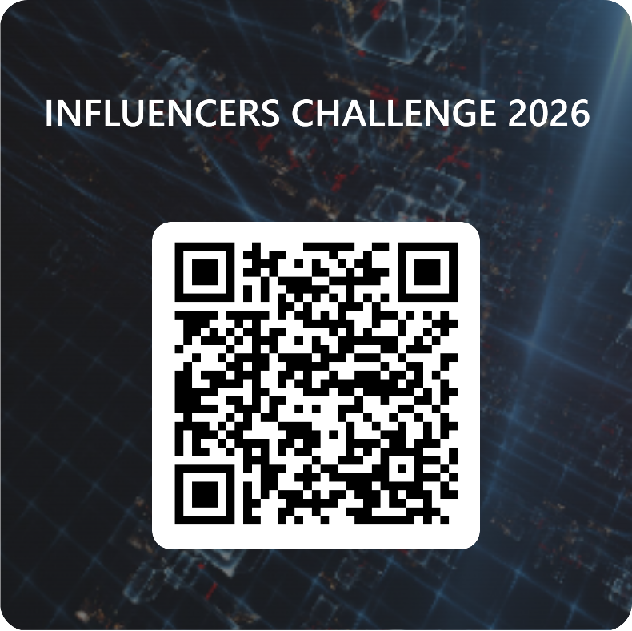

Perfect choice! 🎉
Option B (VS Code + HTML/CSS) will give you a real professional landing page, the kind startups use for launch events.
I will guide you EXACTLY like a senior frontend developer guiding a beginner.
From now onward, you don’t need to think —
just follow my steps one-by-one.

⭐ OVERVIEW: What we will build
A premium landing page with:
✔ Hero banner
✔ Highlights
✔ Who can apply
✔ Steps to participate
✔ QR Code section
✔ Footer
✔ Buttons (Register Now)
✔ Fully mobile responsive
✔ Your images + theme (blue neon)
Sample structure:
index.html
style.css
assets/
hero-banner.png
qr-code.png
You already have hero banner.
You have QR code.
We will assemble everything.

⭐ STEP 1 — Create project folder
Create a folder anywhere:
influencers-challenge-2026
Inside it:
- index.html
- style.css
- assets/ (folder for images)
Place your images inside assets:
- hero-banner.png (your neon header image)
- qr.png (your QR code)

⭐ STEP 2 — Open folder in VS Code
- Open VS Code
- File → Open Folder
- Select influencers-challenge-2026
Your workspace is ready.

⭐ STEP 3 — Create index.html
Copy–paste this full file:
<!DOCTYPE html>
<html lang="en">
<head>
<meta charset="UTF-8">
<meta name="viewport" content="width=device-width, initial-scale=1.0">
<title>Jack Marvels – Influencers Challenge 2026</title>
<link rel="stylesheet" href="style.css">
</head>
<body>

<!-- HERO SECTION -->
<section class="hero">
<img src="assets/hero-banner.png" class="hero-img" alt="Influencers Challenge 2026">
<div class="hero-text">
<h1>JACK MARVELS – INFLUENCERS CHALLENGE 2026</h1>
<h2>Creators. Community. Impact.</h2>
<p>Join India’s most exciting creator challenge of 2026! Stand out, collaborate, and get featured on the Jack Marvels app. Limited entries — register now.</p>
<a href="https://forms.microsoft.com/r/3XkcWD6uNx" class="btn">Register Now</a>
</div>
</section>

<!-- HIGHLIGHTS SECTION -->
<section class="section">
<h2>Why Join the Jack Marvels Influencers Challenge?</h2>
<ul>
<li>🔥 <b>Creator Spotlight:</b> Get featured on the Jack Marvels app.</li>
<li>🎁 <b>Free Product Kits:</b> Receive exclusive creator packs.</li>
<li>🎥 <b>Challenge-Based Tasks:</b> Showcase reels and short videos.</li>
<li>🤝 <b>Collaboration Opportunities:</b> Join our creator community.</li>
<li>🏆 <b>Awards & Recognition:</b> Win badges, prizes, and spotlight.</li>
</ul>
</section>

<!-- WHO CAN APPLY -->
<section class="section dark">
<h2>Who Can Apply?</h2>
<p>This challenge is open to:</p>
<ul>
<li>Beauty creators</li>
<li>Fashion & lifestyle influencers</li>
<li>Tech reviewers</li>
<li>Fitness creators</li>
<li>Comedy & entertainment creators</li>
<li>Travel & food influencers</li>
<li>Education & motivation creators</li>
<li>Micro, mid-tier & macro influencers</li>
</ul>
</section>

<!-- STEPS TO PARTICIPATE -->
<section class="section">
<h2>Steps to Participate</h2>
<ol>
<li><b>Fill the Registration Form:</b> Click the link or scan the QR code.</li>
<li><b>Team Review:</b> We evaluate your profile.</li>
<li><b>Get Selected & Receive Products:</b> Shortlisted creators receive kits.</li>
<li><b>Participate in Challenge:</b> Follow themes & upload creative posts.</li>
<li><b>Win Rewards:</b> Leaderboard winners get spotlight & gifts.</li>
</ol>
</section>

<!-- QR CODE SECTION -->
<section class="section dark qr-section">
<h2>Scan to Register</h2>
<img src="assets/qr.png" class="qr" alt="QR Code">
<p>Use your camera to scan and fill instantly.</p>
</section>

<!-- ABOUT SECTION -->
<section class="section">
<h2>About Jack Marvels</h2>
<p>Jack Marvels is a creator-first brand focused on empowering influencers, connecting creators with opportunities, and building a strong community. We believe creators shape the future — and we’re here to support your journey.</p>
</section>

<!-- FOOTER -->
<footer>
© 2026 Jack Marvels — Creators. Community. Impact.
</footer>

</body>
</html>

⭐ STEP 4 — Create style.css
Copy–paste:
body {
margin: 0;
font-family: 'Poppins', sans-serif;
background-color: #000814;
color: white;
line-height: 1.6;
}

.hero {
position: relative;
text-align: center;
}

.hero-img {
width: 100%;
max-height: 500px;
object-fit: cover;
opacity: 0.85;
}

.hero-text {
position: absolute;
top: 50%;
left: 50%;
transform: translate(-50%, -50%);
width: 80%;
}

.hero-text h1 {
font-size: 42px;
font-weight: 900;
color: #ffffff;
}

.hero-text h2 {
font-size: 20px;
margin-bottom: 10px;
color: #00e0ff;
}

.hero-text p {
font-size: 16px;
max-width: 600px;
margin: auto;
}

.btn {
display: inline-block;
margin-top: 20px;
padding: 12px 30px;
background: #0084ff;
color: white;
font-size: 18px;
border-radius: 6px;
text-decoration: none;
transition: 0.3s;
}

.btn:hover {
background: #00b7ff;
box-shadow: 0 0 10px #00b7ff;
}

.section {
padding: 60px 20px;
max-width: 900px;
margin: auto;
}

.section.dark {
background: #001524;
border-radius: 12px;
}

.qr-section img.qr {
width: 180px;
margin-top: 20px;
border-radius: 10px;
}

footer {
text-align: center;
padding: 20px;
background: #00050a;
margin-top: 40px;
color: #888;
}

⭐ STEP 5 — Open in Browser
Right-click index.html → Open with Live Server
(or just open in browser)
Your landing page is ready 🎉
It will look extremely premium.

⭐ NEXT STEPS (I can help you now with):
✔ Adding animations
✔ Making it mobile-friendly 100%
✔ Adding automatic scroll
✔ Adding an “App Coming Soon” popup
✔ Deploying to GitHub Pages (free hosting)
✔ Custom domain (like jackmarvels.in)

❓ Do you want me to help you deploy this website online?

📌 NEXT QUESTION FOR YOU:
Which enhancement would you like next?
1️⃣ Soft fade-in animation
2️⃣ Floating particles (gold dust)
3️⃣ Premium gold frame around the content
4️⃣ Animated glow on button
5️⃣ Add app download buttons (future ready)
Tell me your choices (e.g., 1 and 4) and I’ll add them perfectly.

/* Background Image */
body {
margin: 0;
padding: 0;
background: url('neon-bg.jpg') no-repeat center center fixed;
background-size: cover;
font-family: 'Poppins', sans-serif;
color: white;
}

/* Center Panel */
.glass-panel {
max-width: 650px;
margin: 0 auto;
margin-top: 40px;
padding: 40px 35px;
background: rgba(0, 0, 0, 0.45);
backdrop-filter: blur(12px);
border-radius: 25px;

/* GLASS SHADOW */
box-shadow: 0px 0px 30px rgba(0, 0, 0, 0.6);
text-align: center;
}

/* Title */
.title {
font-size: 32px;
font-weight: 700;
line-height: 1.3;
margin-bottom: 15px;
color: #ffffff;
text-shadow: 0 0 12px rgba(255, 255, 255, 0.5);
}

/* Tagline */
.tagline {
font-size: 18px;
font-weight: 600;
color: #ffde6b; /* gold accent */
margin-top: 5px;
margin-bottom: 20px;
}

/* Description */
.description {
font-size: 17px;
line-height: 1.6;
opacity: 0.9;
margin-bottom: 35px;
}

/* CTA Button */
.cta-btn {
display: inline-block;
padding: 14px 32px;
background: linear-gradient(90deg, #007bff, #0a84ff);
color: white;
border-radius: 50px;
font-size: 19px;
font-weight: 600;
text-decoration: none;
box-shadow: 0 0 18px rgba(0, 140, 255, 0.8);
transition: 0.25s;
}

.cta-btn:hover {
transform: scale(1.08);
box-shadow: 0 0 30px rgba(0, 140, 255, 1);
}

/* QR Box */
.qr-box img {
margin-top: 30px;
width: 220px;
border-radius: 22px;
box-shadow: 0 0 25px rgba(0, 247, 255, 0.9);
}

/* Footer */
.footer {
margin-top: 35px;
opacity: 0.8;
font-size: 14px;
}

30-12 HOSTING

Perfect 👍
Now I’ll reset my explanation level to ZERO and guide you step-by-step, assuming you don’t know anything.
Follow exactly in this order — don’t skip steps.

🎯 GOAL (Very Simple)
You want:
- Your page visible online
- Share a permanent link to your brother
- Later connect BigRock domain (optional, last step)
Right now you have:
- index.html
- style.css
- images (background, QR)
- Microsoft Form link ✅
Good — that’s ALL you need.

🧱 STEP 1: PREPARE YOUR PROJECT FOLDER (LOCAL)

1️⃣ Folder structure (VERY IMPORTANT)
Your folder must look exactly like this:
alpha-vlogs-2026/
│
├── index.html
├── style.css
│
├── images/
│ ├── background.jpg
│ ├── qr.png
⚠️ Rules:
- No spaces in folder/file names
- All lowercase preferred
- Images inside images/ folder

2️⃣ Check your HTML paths
Open index.html and verify:
<link rel="stylesheet" href="style.css">
For images:
<img src="images/qr.png">
Background in CSS:
background-image: url("images/background.jpg");
👉 If this works locally → it will work online.

🧪 STEP 2: FINAL LOCAL TEST (MANDATORY)

1️⃣ Open index.html in browser
Double click → Chrome opens
Check:
- Background visible
- Text white
- Button clickable
- QR visible
If OK → proceed
If NOT → STOP and fix before hosting

☁️ STEP 3: CREATE GITHUB REPOSITORY (HOSTING)

1️⃣ Go to GitHub
👉 https://github.com
Login

2️⃣ Create new repository
Click New
Fill like this:
- Repository name:
- alpha-vlogs-2026
- Public ✅
- ❌ Don’t add README
- ❌ Don’t add license
Click Create repository

⬆️ STEP 4: UPLOAD YOUR FILES TO GITHUB

Method: Simple Upload (Beginner safe)
1️⃣ Open your new repo
2️⃣ Click Add file → Upload files
3️⃣ Drag ALL files + folders inside:
- index.html
- style.css
- images/ folder
4️⃣ Scroll down
5️⃣ Click Commit changes
✅ Files are now online (but not live yet)

🌍 STEP 5: ENABLE GITHUB PAGES (MOST IMPORTANT)
1️⃣ In repo → click Settings
2️⃣ Left menu → Pages
You will see:

Build and deployment
- Source: Deploy from a branch
- Branch:
  - main
  - /root
Click Save

3️⃣ Wait 30–90 seconds ⏳
GitHub will show:
✅ Your site is published at
https://yourusername.github.io/alpha-vlogs-2026/
🎉 THIS IS YOUR LIVE LINK

🔗 STEP 6: TEST YOUR LIVE LINK
Open link in:
- Desktop browser
- Mobile browser
Check:
- Layout OK
- Button opens Microsoft Form
- QR works
If yes → DONE

📤 STEP 7: SHARE WITH YOUR BROTHER
Send him this message:
Hi bro 👋
The Alpha Vlogs 2026 landing page is live.

Live link:
https://yourusername.github.io/alpha-vlogs-2026/

Please review and let me know:
- Background OK?
- Text OK?
- Any changes needed?
This is professional & clear.

🌐 STEP 8 (OPTIONAL, LATER): CONNECT BIGROCK DOMAIN
⚠️ Do this ONLY after brother approval.

Simple explanation:
- GitHub Pages = house
- BigRock domain = address
Later we will:
- Buy domain on BigRock
- Add DNS records
- Point domain → GitHub Pages
👉 I’ll guide this separately, step-by-step.

✅ CURRENT STATUS CHECK
You are now at:
✔ Design done
✔ Page built
✔ Hosting ready
✔ Shareable link available
This is real-world deployment, not tutorial stuff.

👉 NEXT — Tell me:
1️⃣ You want DNS + BigRock setup
2️⃣ You want form optimization & auto-reply text
3️⃣ You want analytics + tracking
4️⃣ You want final polish review
Reply with the number.

BIGROCKS

Perfect 👍
You’re at the exact right point. I’ll guide you step-by-step, assuming you have BigRock access and GitHub Pages is already live.
No confusion, no Enterprise, no paid hosting needed.

🧭 BIG PICTURE (VERY IMPORTANT – READ ONCE)
- Hosting → GitHub Pages (FREE, already working)
- Domain → BigRock (ONLY name pointing)
- You are NOT buying hosting on BigRock
- You are NOT using GitHub Enterprise
- This setup is industry-standard & permanent

✅ STEP 1: CHECK DOMAIN AVAILABILITY ON BIGROCK

Login to BigRock
👉 https://www.bigrock.in

In the search bar:
Search for:
alphavlogs.in

If available:
✔️ Buy it
✔️ Use 1 year (enough)
✔️ Add Domain Privacy if available (optional)
⚠️ You do NOT need:
- Web hosting
- Email hosting
- Website builder
👉 Only domain purchase

✅ STEP 2: KEEP GITHUB PAGES READY (YOU ALREADY DID MOST)
From your screenshot, you are here:
Settings → Pages

Do THIS:
- Source → Deploy from a branch
- Branch → main
- Folder → / (root)
- Click Save
⏳ Wait 1–2 minutes
You should see:
Your site is published at:
https://charangoturu.github.io/alpha-vlogs-2026/
✅ This confirms hosting is LIVE
⚠️ Ignore “Enterprise” — it is NOT required

✅ STEP 3: ADD CUSTOM DOMAIN IN GITHUB (VERY IMPORTANT)
Still in:
Settings → Pages

Find Custom domain
Enter:
alphavlogs.in
Click Save
GitHub will:
- Create a CNAME record internally
- Show DNS instructions (we’ll match them in BigRock)
⚠️ It may show “DNS check failed” now — NORMAL

✅ STEP 4: CONFIGURE BIGROCK DNS (MOST IMPORTANT STEP)

In BigRock:
Go to:
Domain → Manage → DNS Management → Manage DNS
You will add 4 A records + 1 CNAME

🔹 A RECORDS (ADD ALL 4)
Type | Host | Value | TTL
A | @ | 185.199.108.153 | Automatic
A | @ | 185.199.109.153 | Automatic
A | @ | 185.199.110.153 | Automatic
A | @ | 185.199.111.153 | Automatic
👉 These point your domain to GitHub Pages servers

🔹 CNAME RECORD (ADD THIS)
Type | Host | Value
CNAME | www | charangoturu.github.io
⚠️ No https://
⚠️ No trailing slash

✅ STEP 5: WAIT (IMPORTANT – DON’T PANIC)
⏳ DNS takes:
- 10 minutes → 1 hour usually
- Sometimes up to 24 hours
During this time:
- GitHub Pages may show warnings
- Site may partially load
This is normal

✅ STEP 6: ENABLE HTTPS (FINAL TOUCH)
After DNS propagates:
Go back to:
GitHub → Settings → Pages
✔️ Tick:
Enforce HTTPS
If disabled → wait more time and refresh

🎯 FINAL RESULT (WHAT YOUR BRO WILL SEE)
Instead of:
charangoturu.github.io/alpha-vlogs-2026
You’ll have:
https://alphavlogs.in
✔️ Premium
✔️ Shareable
✔️ Works on mobile & desktop
✔️ QR-code friendly
✔️ Safe for launch events

🚀 AFTER THIS (NEXT PROCESS STEPS)
Once domain is live, next things to do:
1️⃣ Update QR code → use alphavlogs.in
2️⃣ Share link with your brother for final approval
3️⃣ Lock Microsoft Form (stop edits before launch)
4️⃣ Optional: add Google Analytics / Clarity later

👉 NOW TELL ME
Reply with ONE of these:
- ✅ “Domain purchased, DNS screen open”
- ❓ “Domain not available”
- 🕒 “DNS added, waiting”
I’ll guide you live for the next exact click.

==============================================================
YES ✅ — this is EXACTLY the correct page. Perfect.
You’re now inside BigRock → DNS Management for alphavlogs.info.
Take a breath 😌 — from here it’s copy–paste level work.

🎯 GOAL (What we are doing now)
We are telling the internet:
“When someone opens alphavlogs.info, show the site hosted on GitHub Pages.”
GitHub Pages hosting = FREE
BigRock domain = just the name

✅ STEP 2: ADD A RECORDS (VERY IMPORTANT)
We’ll add 4 A records (this connects root domain).

🔹 Do this:
Under A (0) → click + Add A Record
You will see fields like:
- Host / Name
- IPv4 Address
- TTL (leave default)

🔢 ADD THESE 4 RECORDS (ONE BY ONE)

🟦 Record 1
- Host / Name: @
- IPv4 Address: 185.199.108.153
- TTL: Default
➡️ Save

🟦 Record 2
- Host / Name: @
- IPv4 Address: 185.199.109.153
➡️ Save

🟦 Record 3
- Host / Name: @
- IPv4 Address: 185.199.110.153
➡️ Save

🟦 Record 4
- Host / Name: @
- IPv4 Address: 185.199.111.153
➡️ Save
👉 After this, A (4) should show.

✅ STEP 3: ADD CNAME RECORD (for www)
Scroll to CNAME (0) → click + Add CNAME Record

🟨 Add this:
- Host / Name: www
- Points To / Value:
- charangoturu.github.io
- TTL: Default
➡️ Save

🚫 DO NOT TOUCH
- ❌ NS records
- ❌ MX / TXT
- ❌ AAAA
Leave them as-is.

✅ STEP 4: CONFIGURE GITHUB PAGES (FINAL LINK)
Now open GitHub repo → Settings → Pages
In Custom domain field, enter:
alphavlogs.info
✔️ Click Save
✔️ Enable Enforce HTTPS (after it appears)

⏳ STEP 5: WAIT (Normal & Expected)
- DNS takes 5–30 minutes (sometimes up to 1 hour)
- Don’t panic if it doesn’t open instantly
Try opening:
- https://alphavlogs.info
- https://www.alphavlogs.info

✅ WHEN YOU’RE DONE, REPLY WITH:
“A records added, CNAME added”
I’ll then:
- Verify everything
- Tell you how to test
- Tell you how to roll back safely if needed
- Guide next production-ready step 🚀
You’re doing real-world hosting work now — excellent progress 💪

Form link for modification

https://forms.microsoft.com/Pages/DesignPageV2.aspx?prevorigin=NeoPortalPage&origin=TemplatePane&linkreferrer=Others&prevsubpage=design&subpage=design&id=DQSIkWdsW0yxEjajBLZtrQAAAAAAAAAAAAN__levl51UMDNUTUZTSjJGTjVPR1FYMUtUQzYyVDVaSi4u&analysis=false

https://forms.microsoft.com/Pages/DesignPageV2.aspx?origin=NeoPortalPage&subpage=design&id=DQSIkWdsW0yxEjajBLZtrQAAAAAAAAAAAAN__levl51UNzExR0g5U0Q4WEw3Vlo5SEsyTUgzSEJNWi4u&preview=%257B%2522ViewModeIndex%2522%3A1%257D

https://forms.microsoft.com/Pages/DesignPageV2.aspx?prevorigin=NeoPortalPage&origin=TemplatePane&linkreferrer=Others&prevsubpage=design&subpage=design&id=DQSIkWdsW0yxEjajBLZtrQAAAAAAAAAAAAN__levl51UMDNUTUZTSjJGTjVPR1FYMUtUQzYyVDVaSi4u&analysis=false&preview=%257B%2522ViewModeIndex%2522%3A1%257D

final –
https://forms.microsoft.com/Pages/DesignPageV2.aspx?prevorigin=NeoPortalPage&origin=TemplatePane&linkreferrer=Others&prevsubpage=design&subpage=design&id=DQSIkWdsW0yxEjajBLZtrQAAAAAAAAAAAAN__levl51UMDNUTUZTSjJGTjVPR1FYMUtUQzYyVDVaSi4u&analysis=false&preview=%257B%2522ViewModeIndex%2522%3A1%257D

2-01-26 FINAL CODE FOR INFLUENCERS FROM PAGE

<!DOCTYPE html>
<html lang="en">
<head>
<meta charset="UTF-8" />
<meta name="viewport" content="width=device-width, initial-scale=1.0" />

<!-- ✅ PAGE TITLE CHANGED -->
<title>INFLUENCERS CHALLENGE 2026</title>

<link rel="stylesheet" href="style.css" />
</head>

<body>
<div class="glass-panel">

<!-- 🔷 LOGO PLACEHOLDER (BRO WILL SHARE LATER) -->
<!-- <img src="logo.png" alt="Event Logo" class="logo" /> -->

<h1 class="title">INFLUENCERS CHALLENGE 2026</h1>
<h2 class="tagline">Powered by Jack Marvels</h2>

<!-- 🔹 CONTENT (UNCHANGED PREMIUM STRUCTURE) -->
<div class="content">

<p class="intro">
Alpha Vlogs Influencer Challenge 2026, presented by Marvels Magazine, is a high-impact creator showcase designed to spotlight India’s most exciting digital talent.
</p>

<h3 class="section-title">Who Can Participate</h3>
<p class="section-text">
We invite creators from all niches — dancers, singers, artists, storytellers, and performers — to step into the Alpha Vlogs Green Room and create viral-ready content.
</p>

<h3 class="section-title">The Challenge</h3>
<ul class="feature-list">
<li>Tongue Twisters — speed, clarity, confidence</li>
<li>Sufi Soul — sing a line from a classic masterpiece</li>
<li>Cinema Magic — deliver a legendary movie dialogue</li>
<li>The Vibe — dance moves or expressive shayari</li>
<li>Creator Corner — art, craft, or a quick DIY hack</li>
</ul>

<h3 class="section-title">How You Win ₹10,00,000</h3>
<ol class="steps-list">
<li>Perform in the Green Room with our professional crew</li>
<li>Your video is published on Alpha Vlogs YouTube</li>
<li>After 10 days, the highest-viewed creator wins ₹10 Lakh cash</li>
</ol>

<h3 class="section-title">Guaranteed Rewards for All</h3>
<p class="section-text">
Every enrolled influencer receives a premium Welcome Kit worth ₹5,00,000.
</p>

<ul class="rewards-list">
<li>Urban Tax CA Services — ₹1,00,000 coupon (2 years validity)</li>
<li>True Black Coffee — ₹25,000 cash coupon</li>
<li>Skin Vida — ₹25,000 premium skincare coupon</li>
<li>Exclusive lifestyle and brand vouchers</li>
</ul>

<div class="event-info">
<p><strong>Entry Fee:</strong> FREE (Exclusive for Influencers)</p>
<p><strong>Location:</strong> Green Room @ Prime Arena Cricket Ground</p>
<p><strong>Date:</strong> 2026 (Exact date to be announced)</p>
</div>

</div>

<!-- 🔵 CTA -->
<a href="https://forms.microsoft.com/r/3XkcWD6uNx" class="cta-btn">
Register Now
</a>

<!-- 🔳 QR -->
<div class="qr-box">
<img src="qr-code.png" alt="QR Code" />
</div>

<!-- ✅ NEW: CONTACT SECTION -->
<div class="contact-section">
<p><strong>Email:</strong> contact@influencerschallenge.com</p>
<p><strong>Address:</strong> Prime Arena Cricket Ground, Green Room Studio, India</p>
<p>
<strong>Instagram:</strong>
<a href="https://instagram.com/marvelsglobalmagazine" target="_blank">@marvelsglobalmagazine</a>
</p>
</div>

<p class="footer">
© 2026 Influencers Challenge — Creators. Community. Impact.
</p>

</div>
</body>
</html>

STYLE.CSS

/* Background Image */
body {
margin: 0;
padding: 0;
background: url('bg1.jpg') no-repeat center center fixed;
background-size: cover;
font-family: 'Poppins', sans-serif;
color: white;
}

/* Center Panel */
.glass-panel {
max-width: 650px;
margin: 0 auto;
margin-top: 40px;
padding: 40px 35px;
background: rgba(0, 0, 0, 0.45);
backdrop-filter: blur(12px);
border-radius: 25px;

/* GLASS SHADOW */
box-shadow: 0px 0px 30px rgba(0, 0, 0, 0.6);
text-align: center;
}

/* Title */
.title {
font-size: 32px;
font-weight: 700;
line-height: 1.3;
margin-bottom: 15px;
color: #ffffff;
text-shadow: 0 0 12px rgba(255, 255, 255, 0.5);
}

/* Tagline */
.tagline {
font-size: 18px;
font-weight: 600;
color: #ffde6b; /* gold accent */
margin-top: 5px;
margin-bottom: 20px;
}

/* Description */
.description {
font-size: 17px;
line-height: 1.6;
opacity: 0.9;
margin-bottom: 35px;
}

/* CTA Button */
.cta-btn {
display: inline-block;
padding: 14px 32px;
background: linear-gradient(90deg, #007bff, #0a84ff);
color: white;
border-radius: 50px;
font-size: 19px;
font-weight: 600;
text-decoration: none;
box-shadow: 0 0 18px rgba(0, 140, 255, 0.8);
transition: 0.25s;
}

.cta-btn:hover {
transform: scale(1.08);
box-shadow: 0 0 30px rgba(0, 140, 255, 1);
}

/* QR Box */
.qr-box img {
margin-top: 30px;
width: 220px;
border-radius: 22px;
box-shadow: 0 0 25px rgba(0, 247, 255, 0.9);
}

/* Footer */
.footer {
margin-top: 35px;
opacity: 0.8;
font-size: 14px;
}

/* 2 */

.content {
text-align: left;
margin-top: 10px;
}

.intro {
font-size: 18px;
line-height: 1.7;
opacity: 0.95;
margin-bottom: 30px;
}

.section-title {
font-size: 20px;
margin-top: 28px;
margin-bottom: 10px;
color: #ffde6b;
}

.section-text {
font-size: 16px;
line-height: 1.6;
opacity: 0.9;
}

.feature-list,
.rewards-list {
list-style: none;
padding-left: 0;
margin-top: 10px;
}

.feature-list li,
.rewards-list li {
margin-bottom: 10px;
padding-left: 18px;
position: relative;
}

.feature-list li::before,
.rewards-list li::before {
content: "•";
position: absolute;
left: 0;
color: #0a84ff;
}

.steps-list {
padding-left: 20px;
margin-top: 10px;
}

.steps-list li {
margin-bottom: 10px;
}

.event-info {
margin-top: 30px;
padding-top: 15px;
border-top: 1px solid rgba(255,255,255,0.2);
font-size: 15px;
opacity: 0.9;
}

/* 3 */
/* LOGO (for future use) */
.logo {
width: 120px;
margin-bottom: 15px;
}

/* CONTACT SECTION */
.contact-section {
margin-top: 35px;
padding-top: 20px;
border-top: 1px solid rgba(255, 255, 255, 0.2);
font-size: 15px;
opacity: 0.9;
text-align: center;
}

.contact-section p {
margin: 8px 0;
}

.contact-section a {
color: #0a84ff;
text-decoration: none;
font-weight: 500;
}

.contact-section a:hover {
text-decoration: underline;
}

